DB Restore from Azure SQL DB to onPrem and Vice Versa
Let's divide these tasks into two main topics. The initial segment will delve into the process of deploying databases from local/on-premises environments to Azure SQL Database. Subsequently, the second topic will outline the steps involved in deploying databases from Azure SQL Database to an on-premises SQL server.
Topic 1
Deploy Databases from Local/onPrem/ to Azure SQL Database!
Step 1:
Go to the Database and right-click – choose Tasks – Deploy databases to Microsoft Azure SQL Database
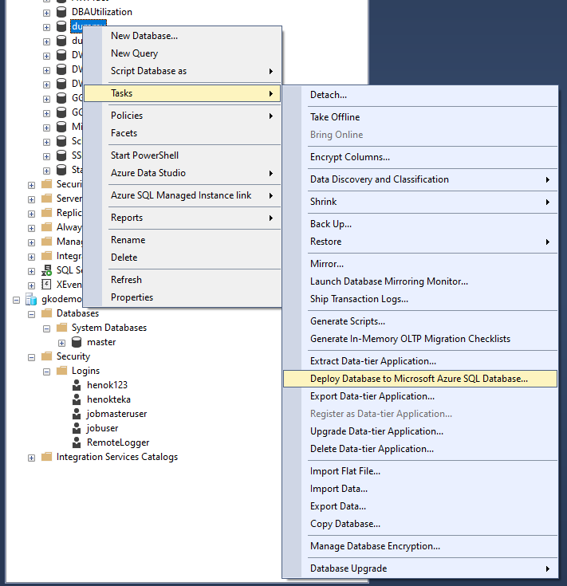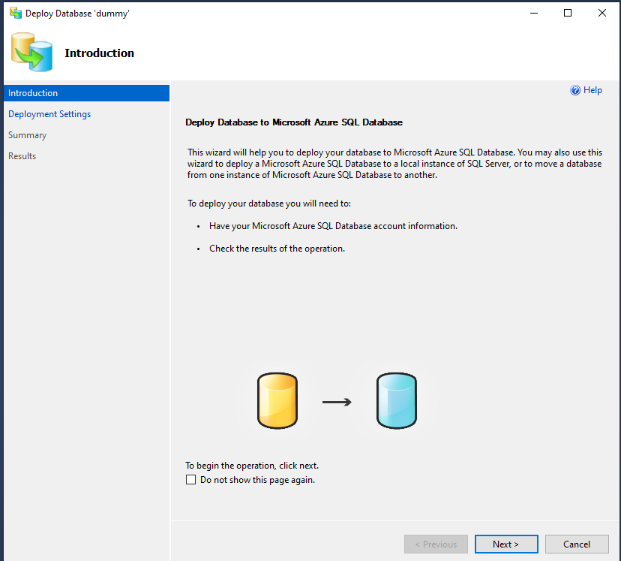
Step 2:
Click next and create connection with Azure Logical SQL Server
- Click connect – and choose the server and login credential.
- Insert the database name.
- Choose the database edition/and setting: basic, standard, etc. Beware that edition type will determine the cost and resiliency.
- Temporary file name (.bacpac) will be automatically assigned.
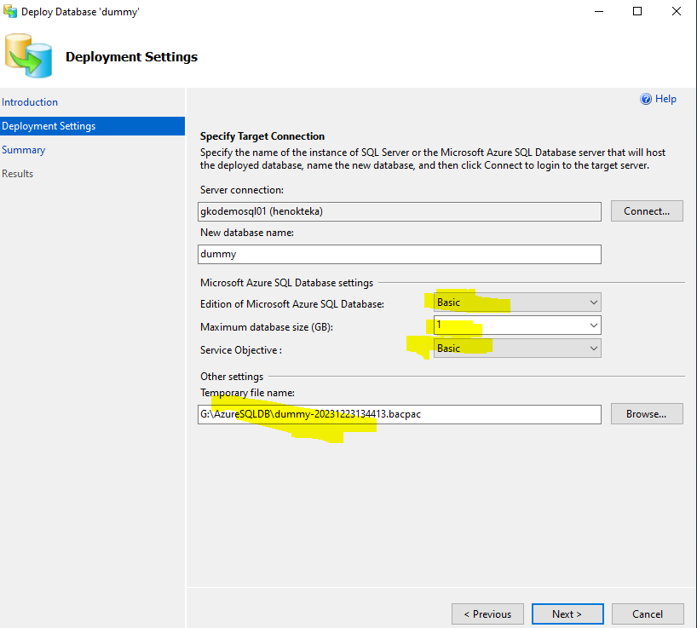
Step 3
Finish the set up and verify!
After clicking the finish button, onPrem SQL database is deployed as Azure SQL database.
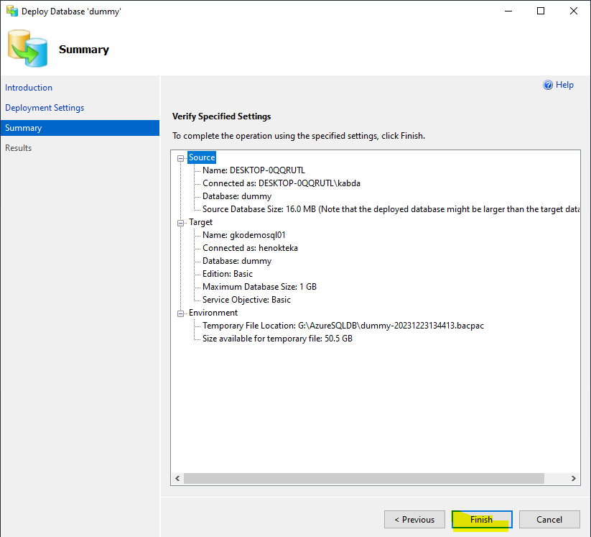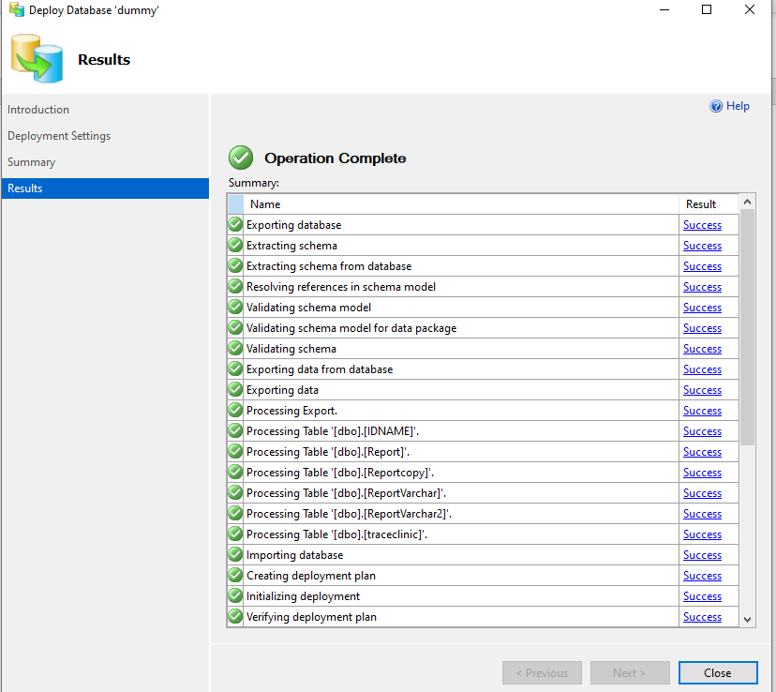
Verify the database is created in the logical server!
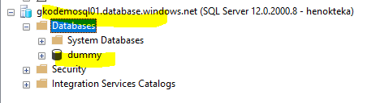

Topic 2
2.0. Deploy Azure SQL Database to onPrem.
(Refreshing/restoring database from Azure SQL database to onPrem)

From Azure SQL Database
SQL Database – task – Deploy databases to Microsoft Azure SQL Database (shown below)

Choose (log in to) the onPrem serve in “deployment setting” step 3 (red),
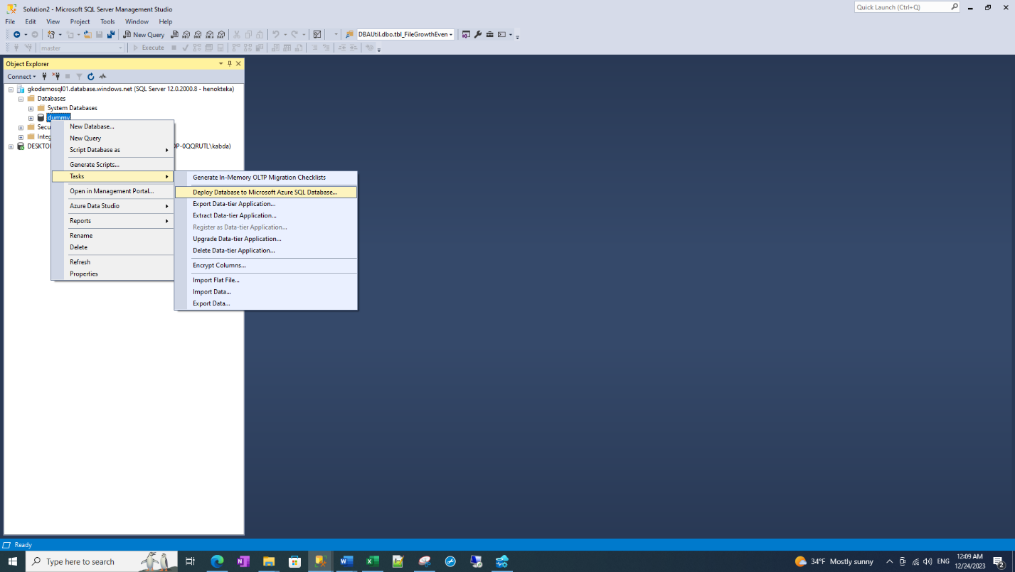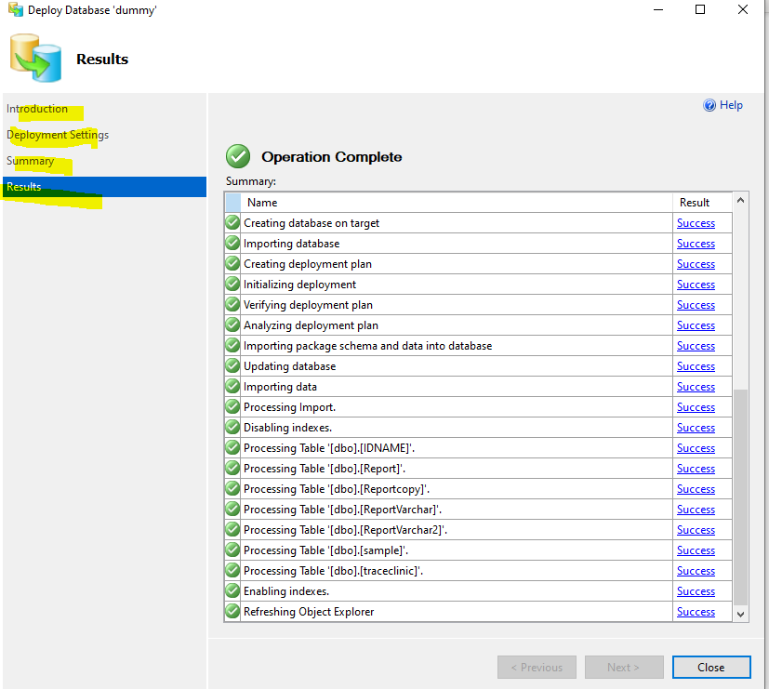
Step 3 above
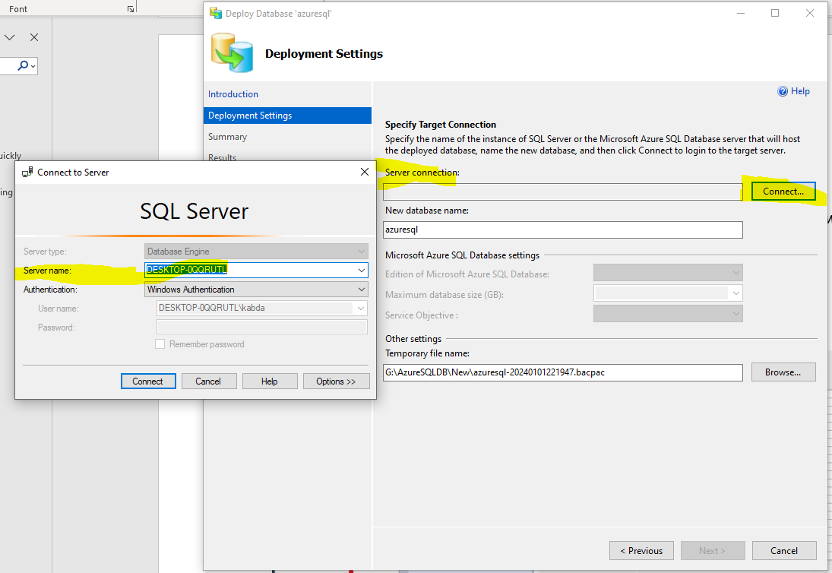
Two options of deployment
- Schema + Data = Export Data-tier Application (.bacpac file type)
- Schema-only = Extract Data-tier Application (.dacpac file type)
Both options are in the picture below.
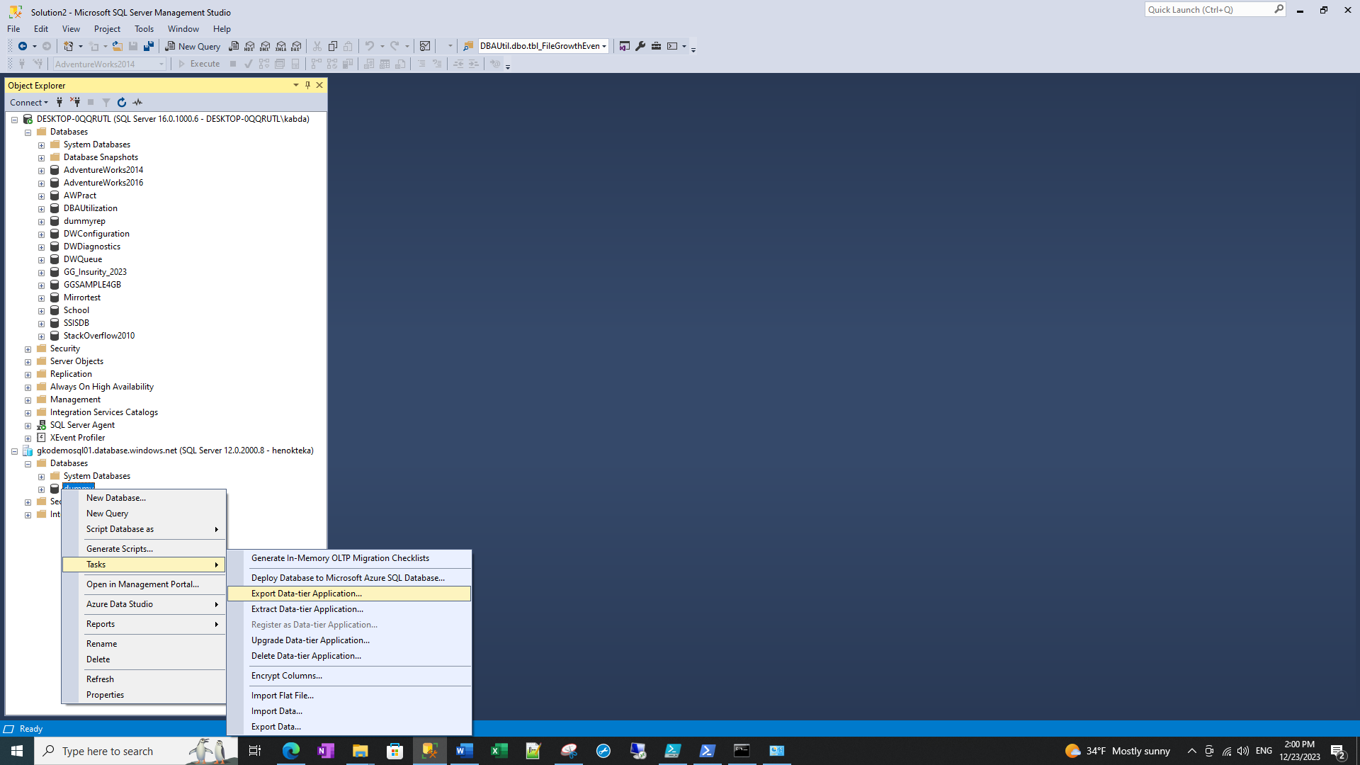
2
1

Export or extract are done in the Azure SQL database, this will help to move the entire database or schema only, respectively.
On the destination- we can “import” the exported .bacpac file (schema and data) using “import data-tier application” or “deploy” the extracted .dacpac (schema only) using “deploy data-tier application”.

Extract and Deploy schema only to onPrem server
In the below example, we will restore the schema only (hence we will choose “EXTRACT Data-tier Application”) – option 2.
We will do a 2-step job:
- Extract database file from Azure SQL database: manually extract the schema-only file (if it is already done, you can go to step 6)
- As discussed above, final data is saved as .DACPAC file to a folder.
- Deploy or backup the .dacpac file to onPrem.
Step 1:
On Azure SQL database click tasks – then Extract Data-tier Application – click next
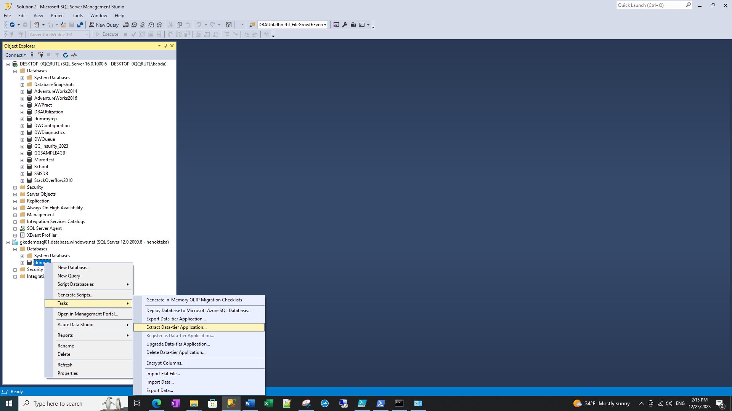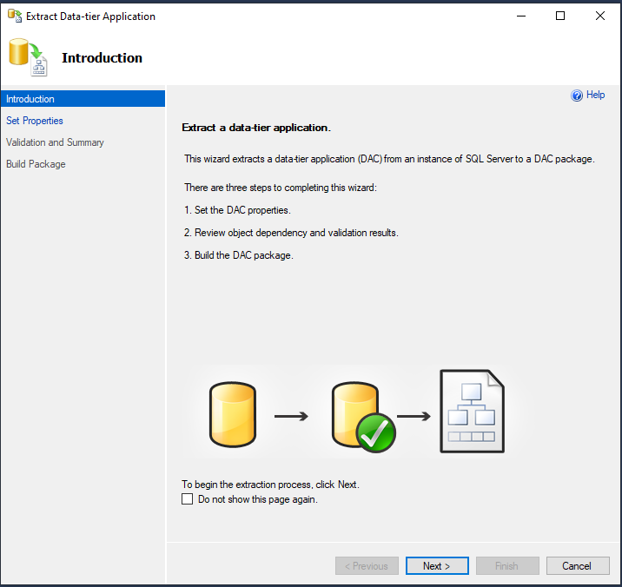
Step 2:
Set properties
- Choose the database name
- Choose the location where you want to save the file for later deployment
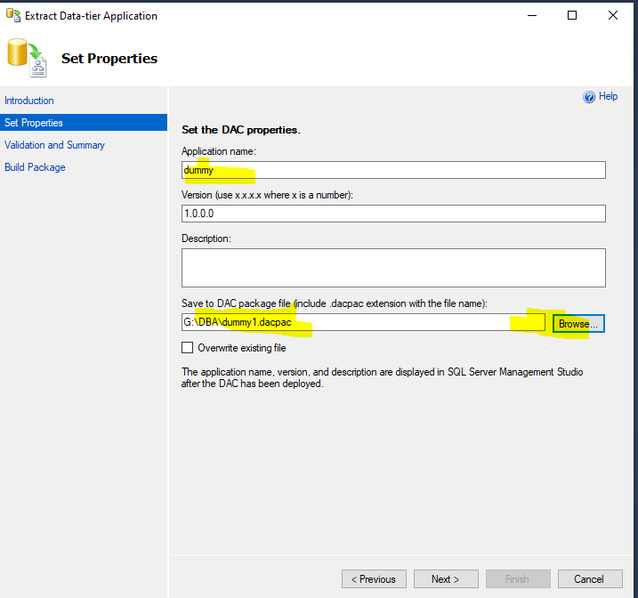
Step 3:
Click and validate.
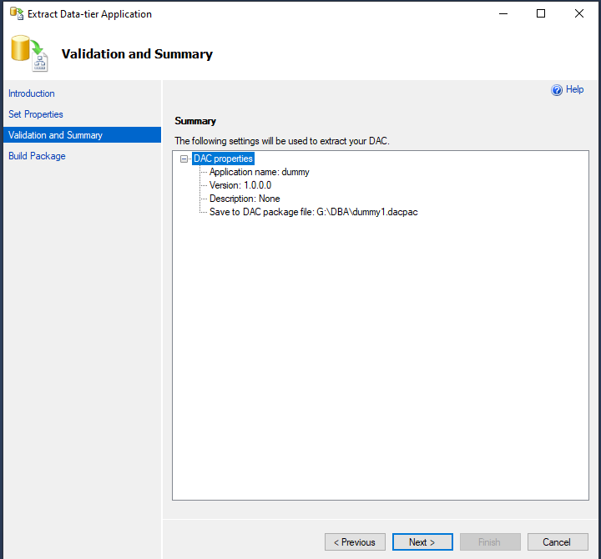
Step 4:
Build/Save the DAC Package or .dacpac file.
This will take some time. Click finish after building.
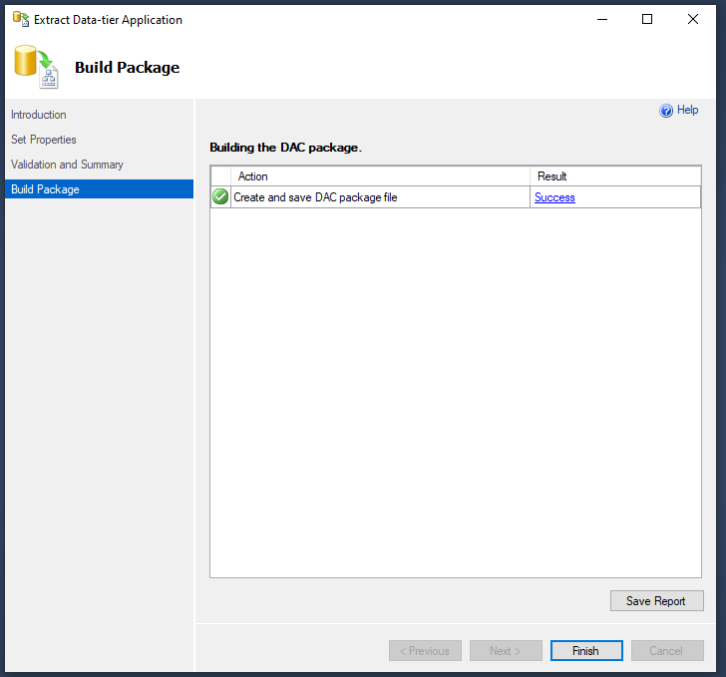
Step 5:
Verify the DAC file is saved in the folder we chose.
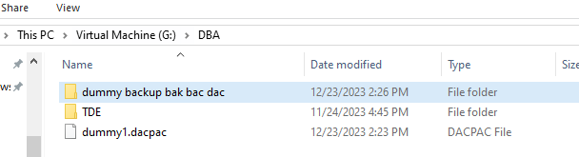
Step 6:
Deploy/Restore from here!
On the onPrem instance, right click on databases and click “Deploy Data-tier Application”. Click next!
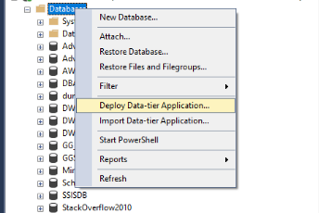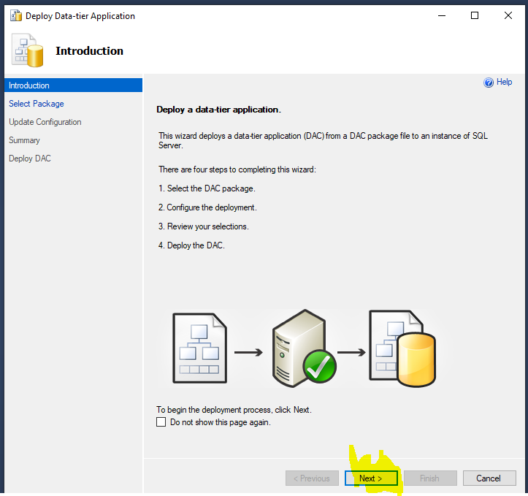
Step 7: Browse and select the dacpac file you saved in the above steps – then click next
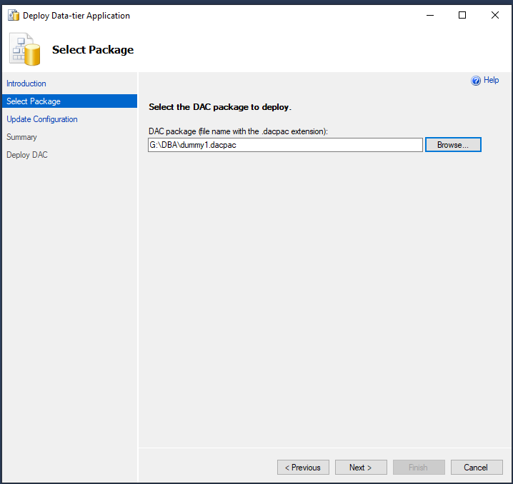
Step 8: name the database and click next
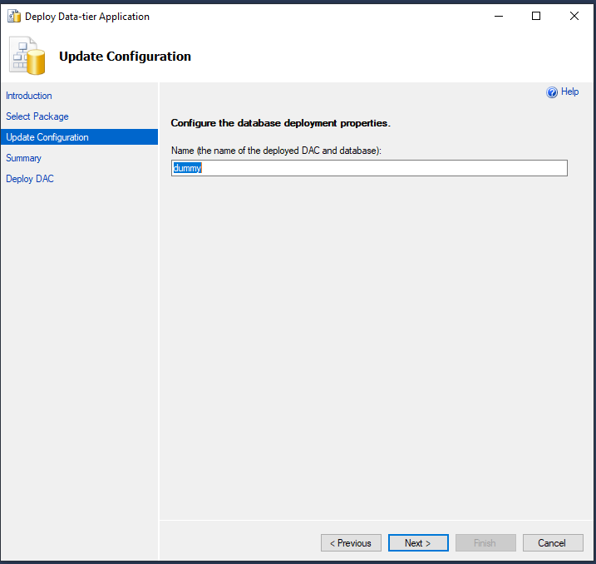
Step 4: validate the summary and deploy.
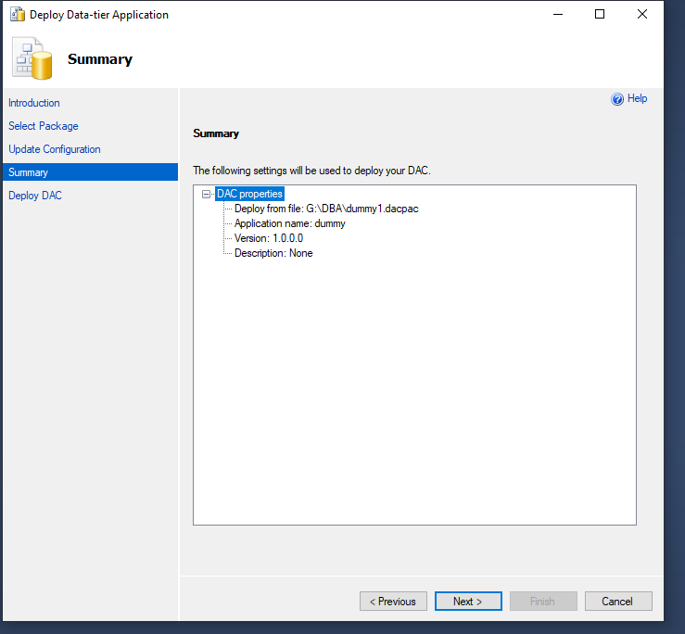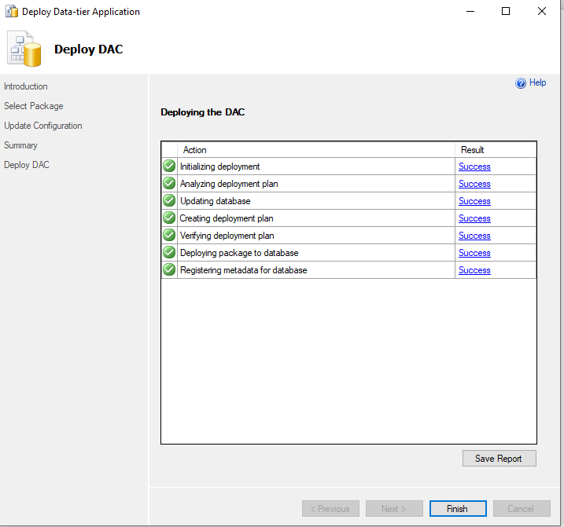
step 5: Finish deploy and validate the creation of the database
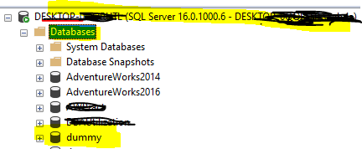
This database is schema only, there is no data in the tables.

Export data-tier from Azure SQL, then import datatier to onPrem
This will export the SQL database as .bacpac file.
On Azure SQL DB, right click and expand “Task” – click “export data-tier application”
(.bacpac file is stored in G drive in this example)
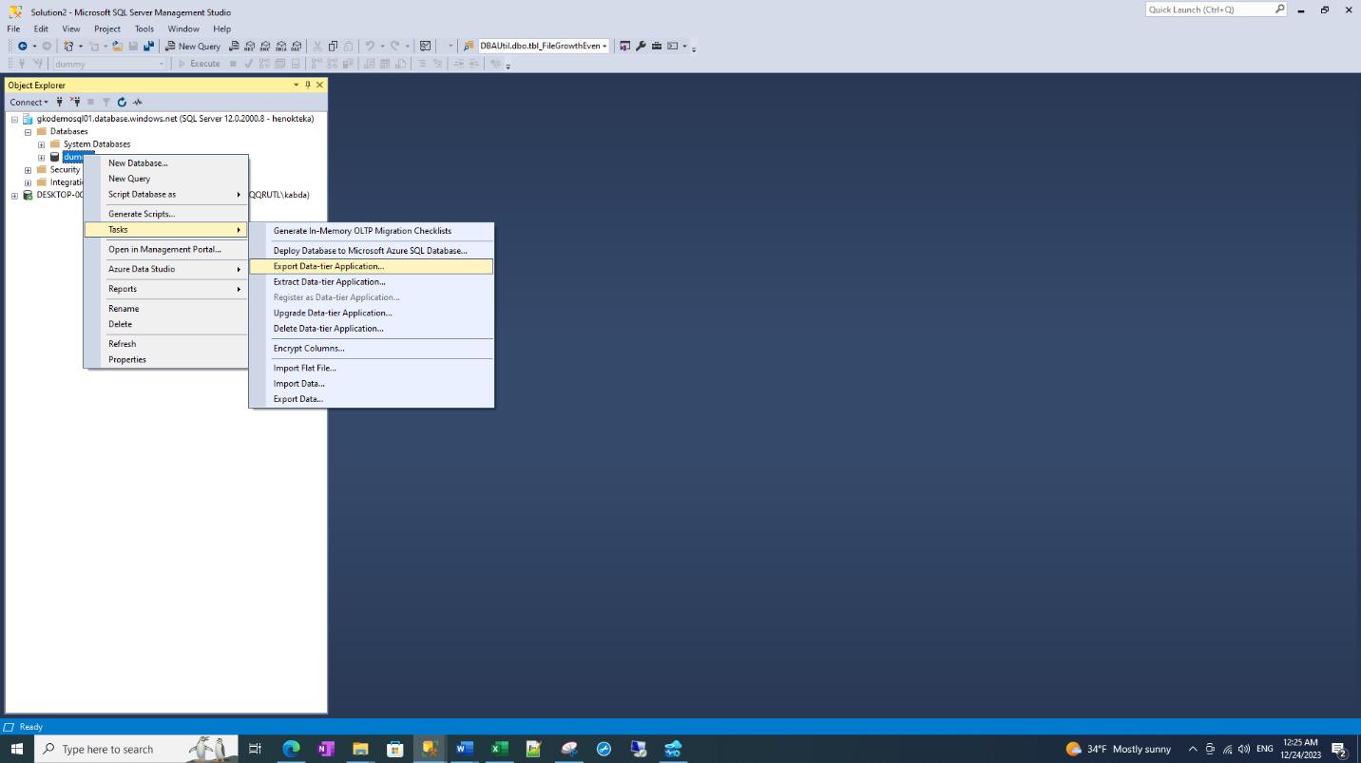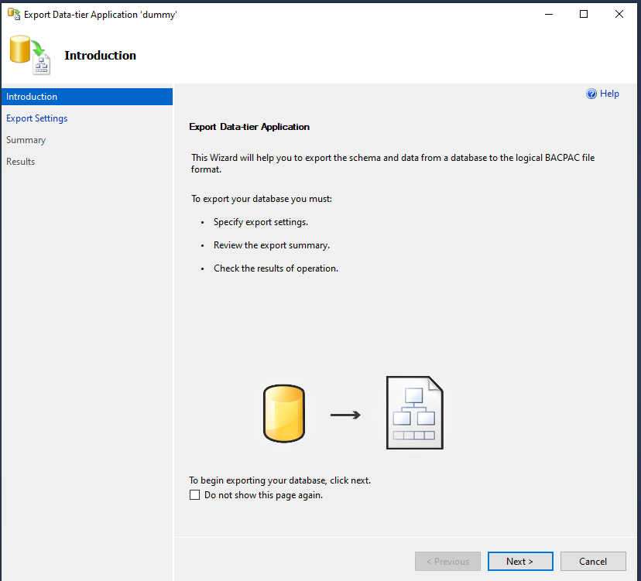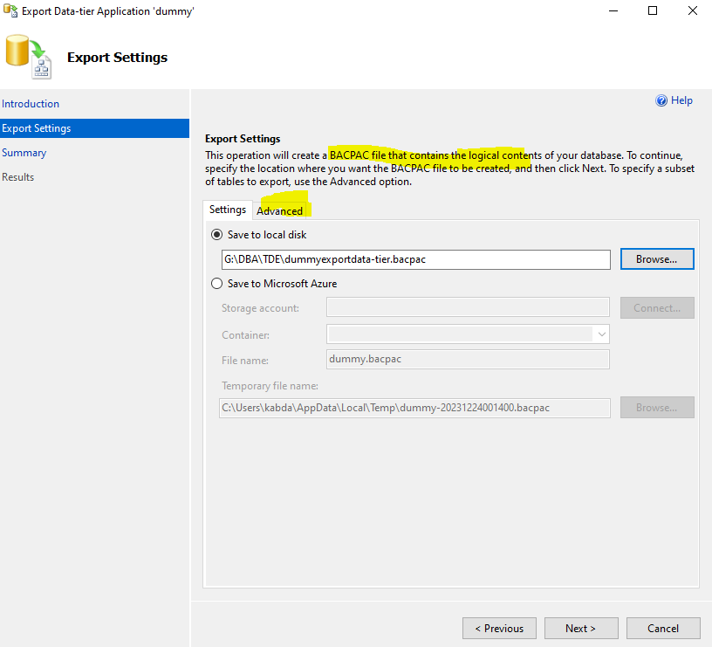
NB: On 3, the advanced option (yellow marked) helps you to deploy specific tables if you don’t want to deploy the entire objects in the database.
NEXT
On onPrem server , use import data-tier application to deploy the database. Then follow the wizard to import the data from where the .bacpac file is stored in the above steps.
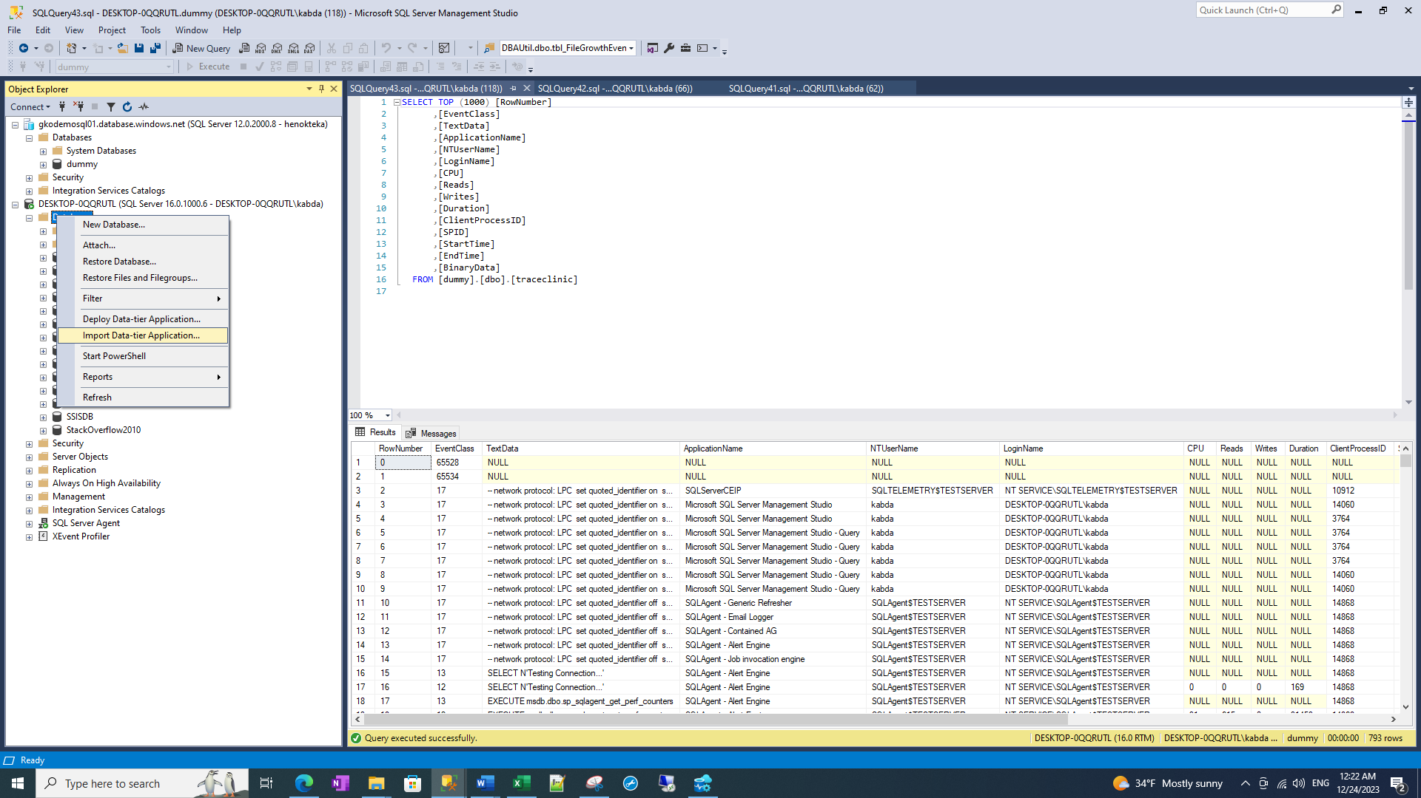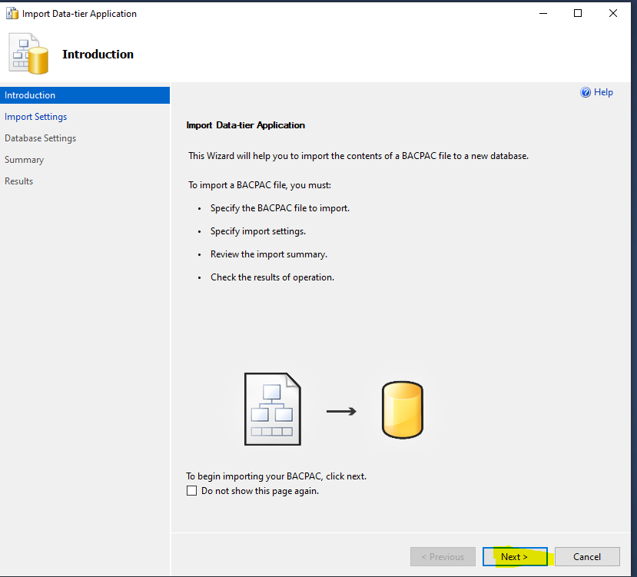

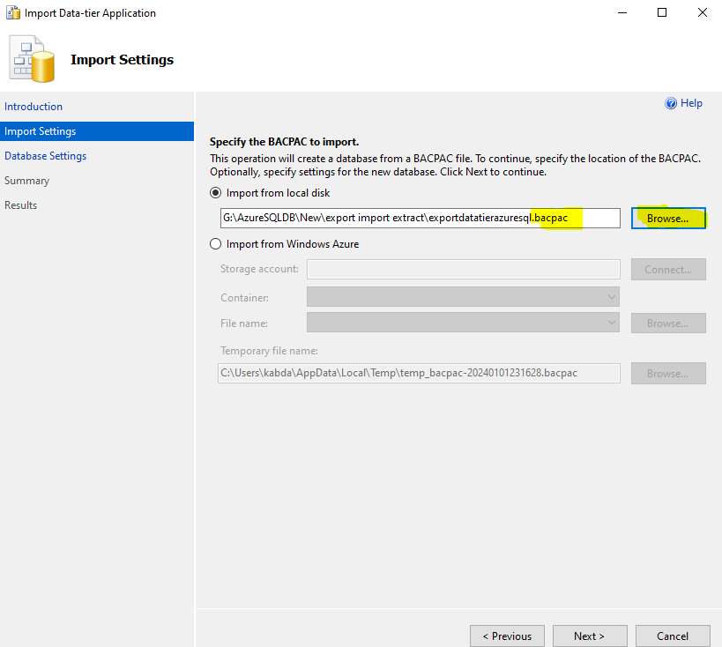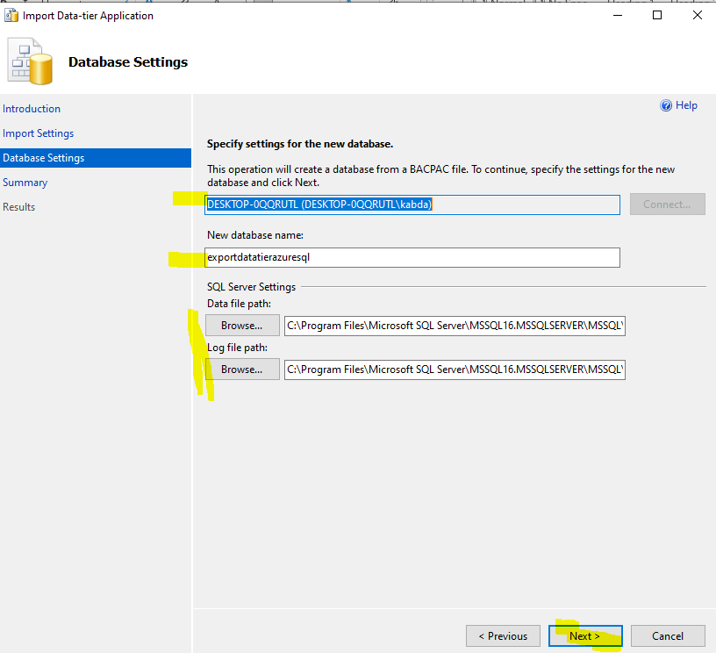
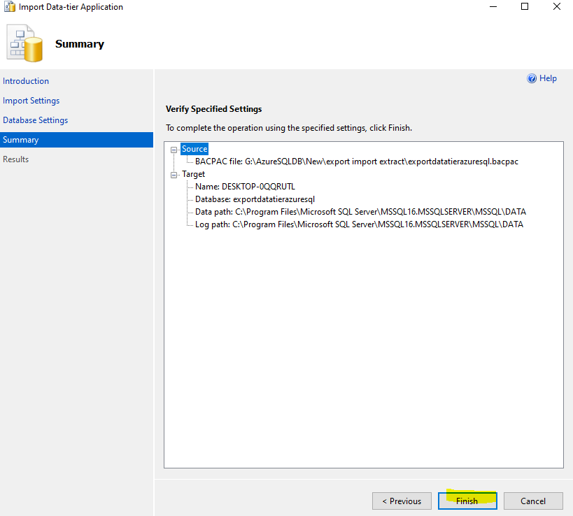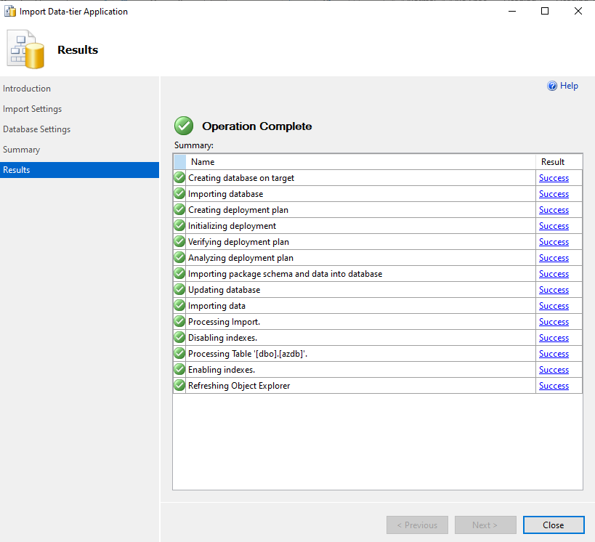
After finishing these steps, verify the database. Here, tables have data.

